**Inheritance and Super keyword**

**Inheritance:**

**-**It is the mechanism in Java by which one class acquire properties and methods of another class.

- Promotes code reusability and method overriding.

- Syntax: class Child extends Parent { }

- Example: Animal is the base class and Dog, Cat and Cow are derived classes that extends the Animal class.

**Types of Inheritance:**

1. **Single Inheritance:**

**-** In single inheritance, a sub-class is derived from only one super class.

**-** It inherits the properties and behaviour of a single-parent class.

**-** Example: Car class is inherits the properties and behaviour of a vehicle class.

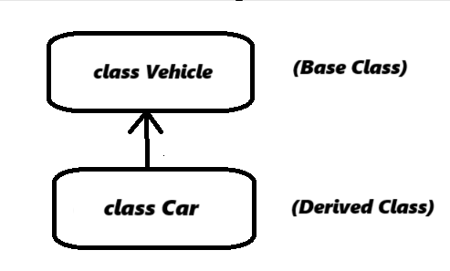

1. **Multilevel Inheritance:**

- In Multilevel inheritance, a derived class will be inheriting a base class and as well as the derived class also acts as the base class for other classes.

- Example: Car class inherits the properties and behaviour of a fourWheeler class and the fourWheeler class inherits the properties and behaviour of a Vehicle class.

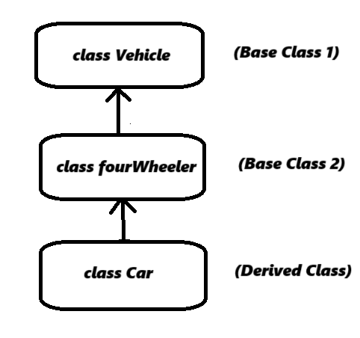

1. **Hierarchical Inheritance:**

- In hierarchical inheritance in which only one base class and multiple derived classes.

- Example: Car and Bike class inherits the properties and behaviour of a Vehicle class.

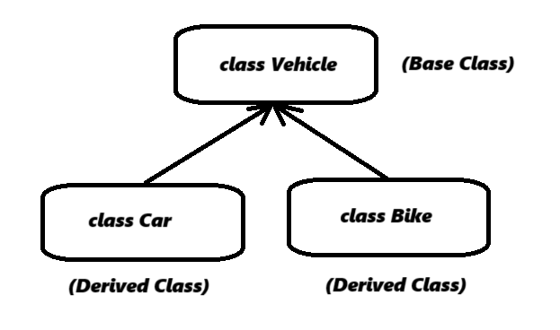

**Super Keyword:**

- The super keyword in Java is a reference variable used within a subclass to refer to its immediate parent class (superclass) object.

- Used to:

* Access parent class variables.
* Call parent class methods.
* Call parent class.

**Is-A Relationship:**

- Dog Is-A Animal.

- Student Is-A Person.

- Helps represent real-world hierarchies.